**Nina Maller and Huiying Li**

**Student ids:**

**604955977 (Nina),**

**304958595 (Huiying)**

**Project 4 Proposal:**

**Design Description:**

In our project, we want to make an air hockey game. This game will support two players, where each will use a PMOD joystick in order to move up, down, left, or right. Every time one person wins (meaning the other lost by missing the ball), the game switches to a score mode, which shows who won the previous round and what are the scores for both players. While looking at the score window, the player can adjust the difficulty using a switch. Then, to go back to the game, then press the continue button. This loops until players decide to stop playing, then they can reset the game.

Here is a photo of how the game will approximately look like: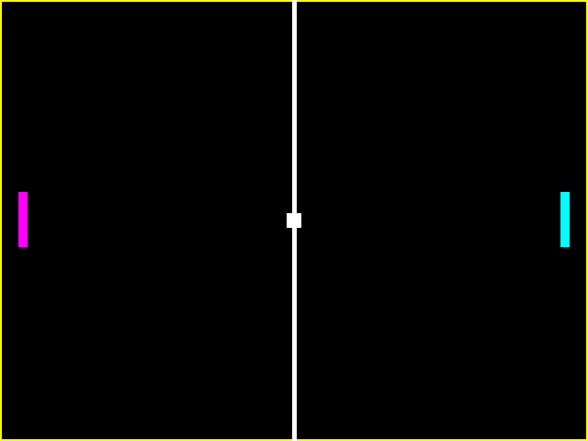

**Design Milestones:**

Movement functionality (25%): Players are able to move up, down, left, and right.

Movement boundaries (25%): Players cannot cross the middle line, nor can they go outside of the rectangle where the game happens. Ball can go on the rectangle, but not outside of it.

Difficulty modes (10%): Players will be able to switch between an easier and a more difficult modes, depending on the speed of the ball, while they are on the score window. If they try to adjust the difficulty while playing, nothing will happen.

Final score mode (15%): This window will show who won the previous round, and the scores of both players. In this window, players will be able to switch between the difficult/easy modes.

Continue functionality (10%): While in the score window, the players can press the continue button in order to continue playing and start the next round. While in game mode, this button will have no functionality.

Game restart functionality (10%): In any mode, in the restart button is pressed, the game will start again and both “final scores” will be reset to 0.

Game pause functionality (10%): In the game mode, if the pause switch is high, the game will stop, and continue when the switch is low again. This functionality will do nothing when in the score window.